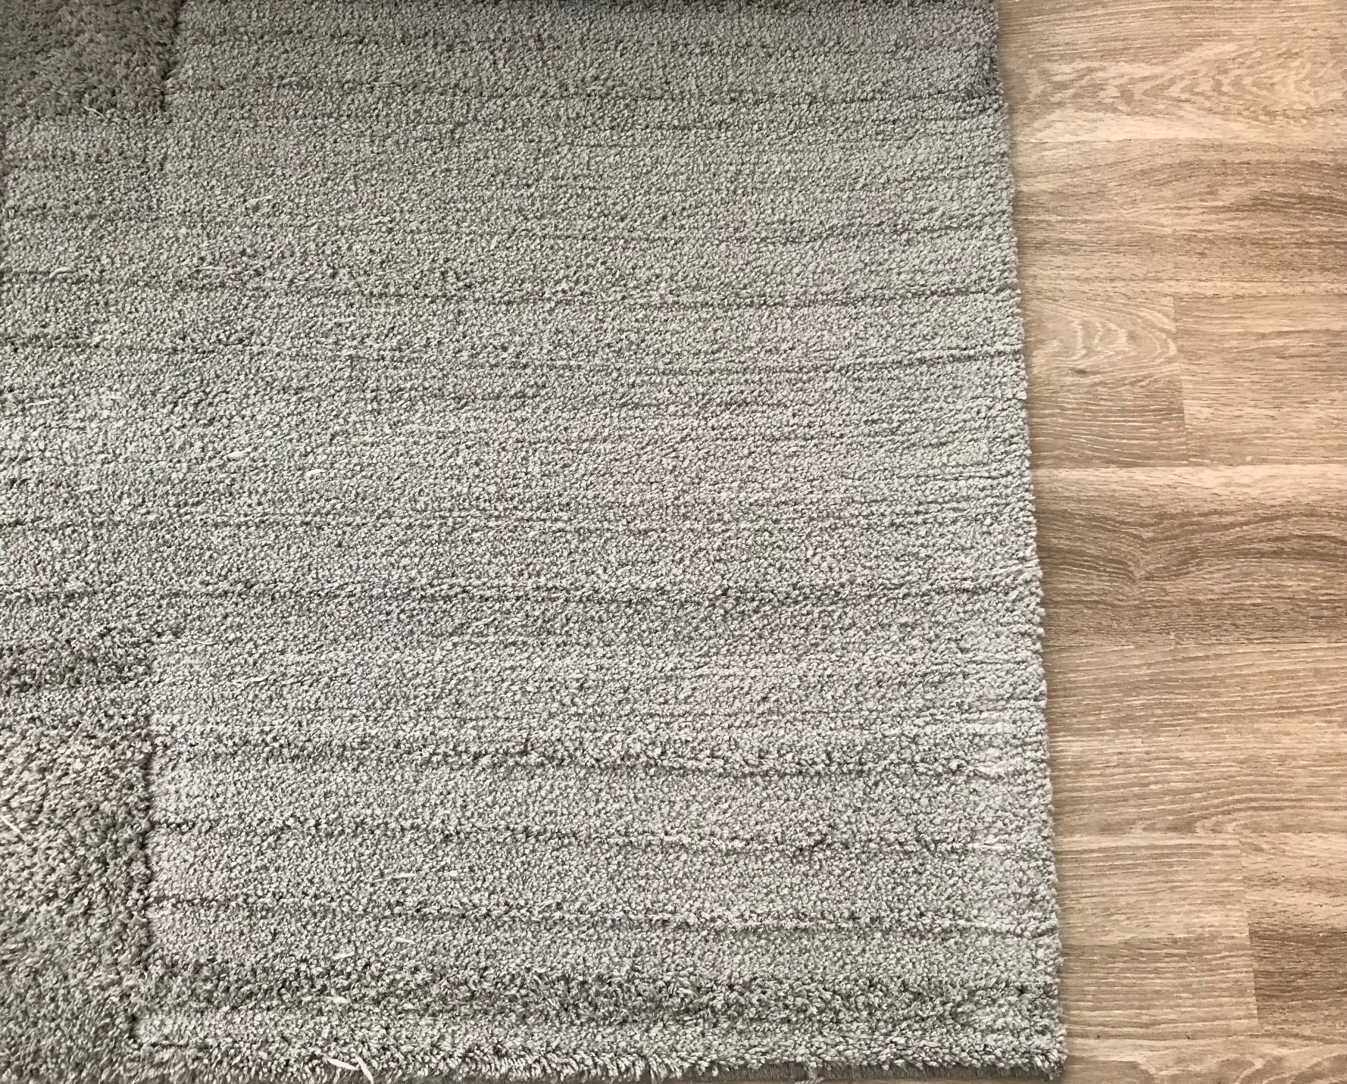

What you see here is a freshly vacuumed carpet. This carpet is in our living room at our home that me and 4 other guys reside in. Before I arrived back to the house, it appears that my one of my roommates had just vacuumed. There is clear data in the pattern of the fabric of the carpet of how he vacuumed and what his technique was. First of all, in relation the how I took the picture, it appears he vacuumed the carpet very symmetrically up and down. I make this assumption because you can see the lighter part of the carpet opposed to the small, symmetrical dark lines equivalently spaced from each other. These lines allow me to make another assumption that there are breaks in the spinning brush which explains as to why there are dark symmetrical lines in the carpet. There are also no signs that the vacuum was turned on the carpet, so I am making another assumption that he realigned the vacuum on the wood floor below. Another assumption I can make is that the carpet has a significant less amount of dirt and dust compared to yesterday. This is also making the assumption that the vacuum was functioning correctly and picking up dirt and dust as most normal vacuums do.

The main conclusion we get out of this is that there is visual evidence that the carpet was vacuumed and that we can make an assumption that the carpet is now cleaner compared with the time before it was vacuumed.